Remove all rows where Quantity is less than 2.



Split the Order Date column into separate "Year," "Month," and "Day" columns.

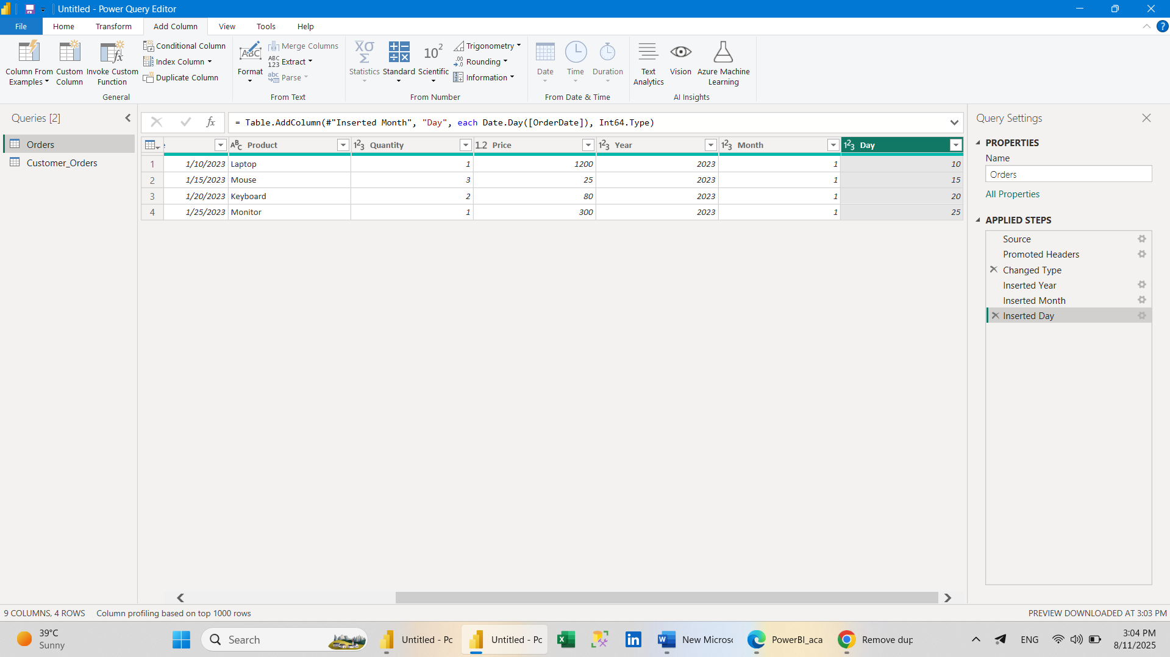

1. Replace all "Mouse" entries in the Product column with "Computer Mouse."
2. Sort the table by OrderDate (newest first).

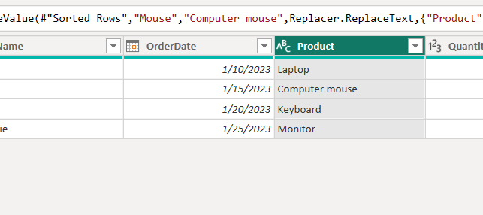

1. How would you handle null values in the Price column?

• **Null qiymatli qatorlarni olib tashlash**

* **Price** ustunini tanlang.
* **Home** → **Remove Rows** → **Remove Blank Rows** tugmasini bosing.  
  (Power Query’da bo‘sh kataklar *null* sifatida ko‘riladi).

• **Null qiymatlarni aniq bir qiymatga almashtirish**

* **Price** ustunini tanlang.
* **Transform** → **Replace Values** ni bosing.
* **Value to Find** qismiga null yozing.
* **Replace With** qismiga kerakli qiymatni kiriting (masalan, 0).
* Yoki **Transform** → **Replace Errors** tugmasini ham ishlatish mumkin.

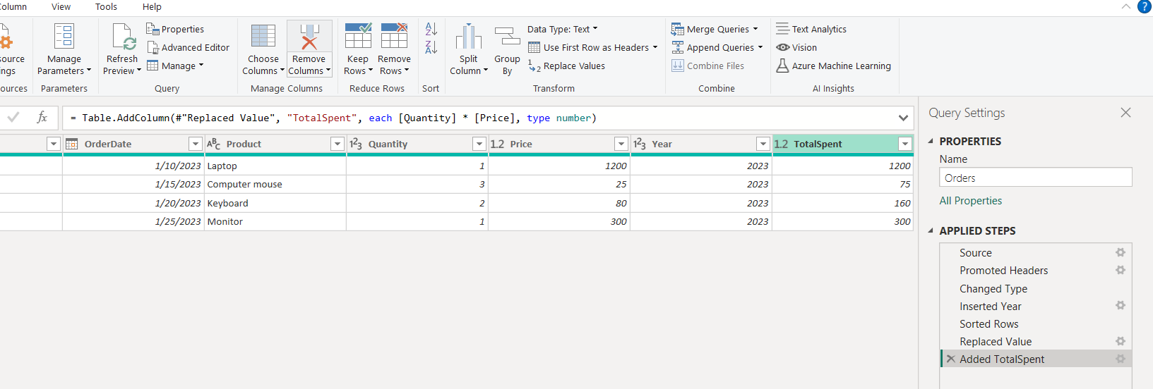

1. Write custom M-code to add a column calculating TotalSpent = Quantity * Price.
2. Group the table by CustID to show total spending per customer.

let

Source = Csv.Document(

File.Contents("C:\Users\MIRZOBEK\Desktop\BI Homeworks\POWER BI\lesson_3_PBI\Orders.txt"),

[Delimiter=",", Columns=6, Encoding=1252, QuoteStyle=QuoteStyle.None]

),

#"Promoted Headers" = Table.PromoteHeaders(Source, [PromoteAllScalars=true]),

#"Changed Type" = Table.TransformColumnTypes(#"Promoted Headers",{{"OrderDate", type date}, {"Quantity", Int64.Type}, {"Price", type number}}),

#"Inserted Year" = Table.AddColumn(#"Changed Type", "Year", each Date.Year([OrderDate]), Int64.Type),

#"Sorted Rows" = Table.Sort(#"Inserted Year",{{"OrderDate", Order.Ascending}}),

#"Replaced Value" = Table.ReplaceValue(#"Sorted Rows","Mouse","Computer mouse",Replacer.ReplaceText,{"Product"}),

#"Added TotalSpent" = Table.AddColumn(#"Replaced Value", "TotalSpent", each [Quantity] * [Price], type number)

in

#"Added TotalSpent"

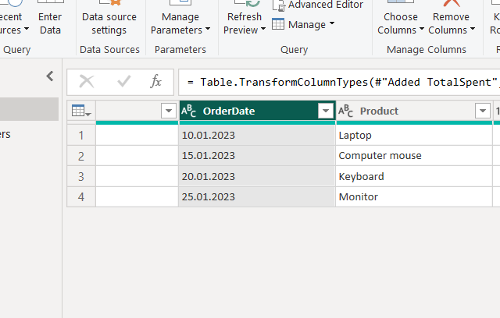

1. Create a conditional column: Label orders as "High Value" if Price > 100.

